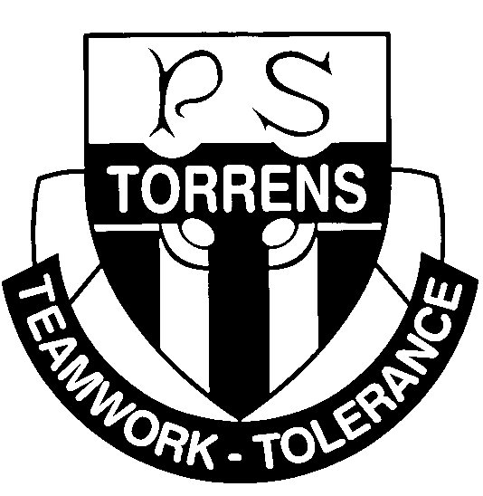
Torrens Primary School
Ritchie Street TORRENS ACT 2607
Phone: 6205.7411
Email: admin@torrensps.act.edu.au Web: www.torrensps.act.edu.au
Torrens Primary School’s Sun Protection Policy and Implementation Plan
Policy Statement
Torrens Primary takes active care to protect children from the most harmful rays of the sun and to educate children to take responsibility for their own safety.
Rationale
The school’s policy is consistent with the Education Directorates Sun Protection Policy.
Policy Outline
- To protect students and minimize activities requiring time outdoors between the hours of 11.00 am and 3.00 pm during daylight saving time and 10.00 am and 2.00 pm during the rest of the year.
- During terms 2 and 3, when there are low UV levels students will not be required wear hats.
- If activities are outdoors, shaded areas will be used as much as possible, particularly during the above hours.
- Children are encouraged to use sunscreen whenever they go outdoors.
- The school uniform includes a range of hats to suit both boys and girls in styles preferred by the children.
- Educational programs relating to sun protection are conducted through the school’s Health and Physical Education Curriculum. Students are regularly reminded about protection needs during school assemblies.
- The parent community is advised of this school policy through the school newsletter and parent meetings.
- Reminders for sunscreen and hats form part of the school excursion notes when applicable.

Responsibilities
Students are responsible for ensuring that they have a hat available at school every day. Broad brimmed hats are recommended.
Teachers actively remind children to take hats outside for playtimes and any outdoor activities. Parents are encouraged to provide hats for their children.
Staff and parents are encouraged to act as role models by practising sun protection behaviours – wearing hats and protective clothing outdoors as well as applying sunscreen.
Non-compliance with the policy
A policy of “No Hat, No Play.” is enforced by the school during terms 1 and 4. Children found not wearing hats outdoors are directed to sit in a specific shaded area.

